Onkar Dhillon

Dr. Chays

CSC 175-002

02/09/2023

ExtractNames.java Output

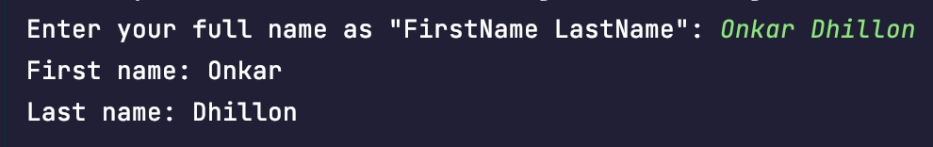

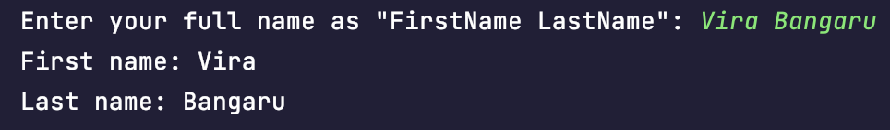

DiceRoller.java Output:

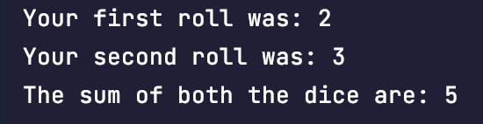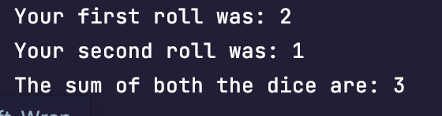

PythagoreanTrigonometricIdentity.java Output:

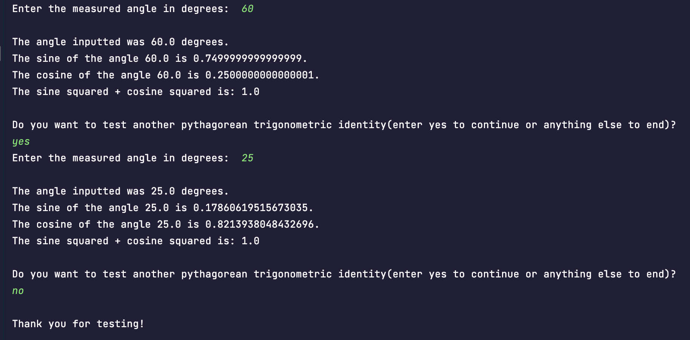

Clock.java

